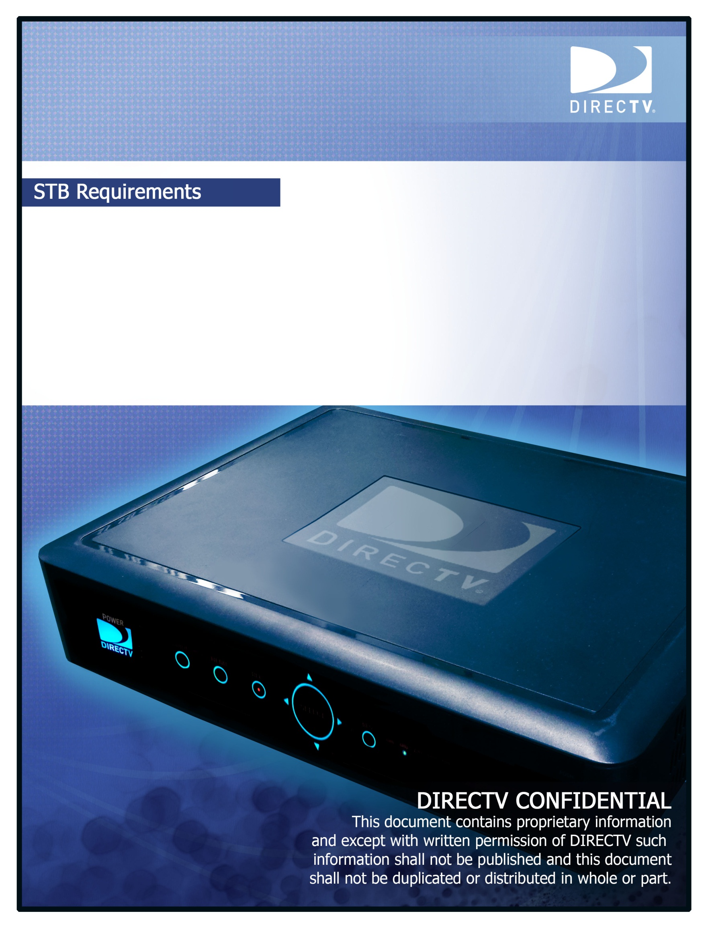

HTML5 Roadmap: JS Control

Version 0.1

Aug 19, 2015

# Document Information and Approvals

## Document Information

|  |  |  |  |  |  |
| --- | --- | --- | --- | --- | --- |
| **Author:** |  | **John Sanders** | | | |
|  |  | |  |  |  |
| **CNF/CR#** | CNF-390 | |  | **Doc. Number:** |  |

## Approvals

|  |  |  |  |
| --- | --- | --- | --- |
| **STB Lead*:** |  | **Date:** |  |
| Pankaj Lenka |
| **Test Lead*:** |  | **Date:** |  |
| tbd |
| **Architecture Lead*:** |  | **Date:** |  |
| tbd |

*\* Document must be physically signed by all mandatory approvers.*

## Disclaimer

DIRECTV makes no representations, express or implied, that use of the technologies described in this specification will not infringe patents, copyrights, or other intellectual property rights of third parties. Nothing in this specification should be construed as granting permission to use any of the technologies described. Anyone planning to make use of technology covered by the intellectual property rights of others should first obtain permission from the holder(s) of the rights. This specification is subject to change without notice. DIRECTV, Incorporated, does not accept any responsibility whatsoever for damages or liability, direct or consequential, which may result from use of this specification or any related discussions.

STB Release Matrix

|  |  |  |
| --- | --- | --- |
| Release | Release Date | Version # |
|  |  |  |
|  |  |  |

Revision History

|  |  |  |  |
| --- | --- | --- | --- |
| Author | Version # | Date | Revisions |
| John Sanders | 0.1 | 08/19/2015 | Initial Draft |
|  |  |  |  |

Table of Contents

Document Information and Approvals 2

Document Information 2

Approvals 2

Disclaimer 2

1 Introduction 6

1.1 Scope 6

1.2 Document Overview 6

1.3 Requirements Vocabulary 6

1.4 Requirements Nomenclature 6

1.5 Reference 7

1.6 Glossary 7

2 General Functions 7

2.1 Compliance to Reference Documents 7

2.2 Video Control Capability 7

2.2.1 Application Termination 8

2.2.2 Video Status Exchange 8

~~2.2.3~~ ~~DVR Search~~ 10

~~2.2.4~~ ~~Live TV Support~~ 10

2.2.5 Trickplay 10

2.2.6 VOD and C3 Control 11

2.2.7 Application Control Functionality 12

2.3 On-Screen Displays 13

2.4 Video Control Commands 13

3 Traceability Matrix 15

Table of Figures

Figure 1: Caption Sample 6

Figure 2: Animal Tuners 6

# Introduction

## Scope

This document describes a new feature of supporting Java Script applications for the control of STB video.

## Document Overview

This document defines the core functionality and requirements for general STB functionality.

## Requirements Vocabulary

This section defines the requirements terms in the specification. Example:

|  |  |
| --- | --- |
| Term | Definition |
| Shall | The described behavior is an absolute requirement of this specification. |
| Shall not | The described behavior is an absolute prohibition of this specification. |
| Should | There could be valid reasons in particular circumstances to ignore the described behavior, but the full implications should be understood prior to implementing a different behavior. |
| Should not | There could exist valid reasons in particular circumstances when the described behavior is acceptable, but the full implications should be understood prior to implementing the behavior described with this label. |
| May | The described behavior is optional. |

## Requirements Nomenclature

Each requirement defined in this specification is marked with an identifier in the form described below:

Form: **R[x-n]**

|  |  |
| --- | --- |
| Nomenclature | Definition |
| R | This character identifies the item as a requirement |
| x | Denotes a section number in this document. |
| n | Denotes a unique requirement number for each section *x*. |

## Reference

|  |  |  |
| --- | --- | --- |
| Ref # | Document # | Document Name |
|  | RQ-GN01-090 | DIRECTV A3 DVR STB Functional Specification : Interactive (iTV and TVApps) |
|  |  | HTML5 Roadmap Phase 1 and 2 System Specification |
|  | ICD-GN01-010 | STB Http Exported Functionality (SHEF) Interface Control Document (ICD) 1.6 |
|  |  | HTML5 A vocabulary and associated APIs for HTML and XHTML  W3C Recommendation 28 October 2014  http://www.w3.org/TR/html5/embedded-content-0.html |
|  |  |  |

## Glossary

|  |  |
| --- | --- |
| Term | Definition |
| STB | Set Top Box |
| APG | Advanced Program Guide |
| Cloud | Search Data retrieved via Broadband Internet |
| Headend | DIRECTV systems that the STB receives either through the Satellite feed or the Internet. |

# General Functions

This section describes all general requirements that must be supported by the STB.

## Compliance to Reference Documents

N/A

## Video Control Capability

R[2.2-1]

The STB shall allow applications to play media from VOD, DVR, MP4, C3, HLS and Live TV through the JavaScript video object.

### Application Termination

R[2.2.1-2]

The STB shall not automatically terminate an HTML5 application when:

* Application made call to channel tune
* Application made call to playback VOD/DVR/C3/MP4/HLS
* Application made call to go to live TV
* Application requested Trickplay functionality
* SHEF trickplay command
* Remote control keypress
* Native UI requested entry into review buffer
* App. requested entry into review buffer

R[2.2.1-3]

The STB shall provide the option in the JavaScript layer for the application to terminate itself if required when any case in R[2.2.1-2] is encountered.

R[2.2.1-4]

The STB shall always terminate an application when

* Native UI tunes to new channel
* Native UI starts playback VOD/DVR/C3/MP4

R[2.2.1-5]

The STB shall allow for the application to use callbacks to ensure a clean shutdown when it is required to terminate itself.

### Video Status Exchange

R[2.2.2-1]

The STB shall report the following video status to the application:

* Start of media
* End of media
* Current position
* Buffered position
* Current position relative to buffered position
* Current position relative to program duration

R[2.2.2-2]

The STB shall report the following video errors to the application:

* Internet down
* Link not available
* Playback failed

R[2.2.2-3]

The STB shall report the following OSD states to the application:

* DVR authorization
* Basic authorization
* Insufficient internet speed
* Delete video end of video
* Rewind past flick offset point
* MaterialID not found or no CDN URL on PGWS/CDN on start download
* Download Conflict while downloading VOD
* Server Error in start of C3 download
* Missing Segmented VOD MPD file/init segment on start download
* Missing Etoken in start download
* About to expire program streaming
* Disk full

R[2.2.2-4]

The STB shall report video status to the HTML5 application directly.

R[2.2.2-5]

The STB shall define 2 types of behavior for OSD errors

* STB mandatory display of OSD
* Application receives event notification and handles user experience by suppress or display OSD

R[2.2.2-6]

The STB shall notify the HTML5 application when the OSD appears on screen.

R[2.2.2-7]

All status in R[2.2.1-1] - R[2.2.2-3] should have a mapping to the HTML5 Media element “network state” and “ready state”. See HTML5 A vocabulary [Ref-04].

### Deleted

### Deleted

### Trickplay

R[2.2.5-1]

The STB shall allow applications to perform trickplay with the following video types.

* MP4, HLS - all offset trickplay.
* VOD/c3/DVR/Live – scrub and all offset trickplay.

R[2.2.5-2]

The STB shall not give the trickplay bar the focus if an application displays the trickplay bar.

Note: Viewer’s key presses will go to the app in this case, and the app will control the trickplay bar.

R[2.2.5-3]

The STB shall allow the application to control the functionality that the trickplay bar provides.

* + Fast forward (multiple speeds)
  + Rewind (multiple speeds)
  + Pause
  + Frame-by-frame playback

R[2.2.5-4]

While under the control of a video app, the STB shall ensure the channel banner and trickplay bar content/description relates to the underlying video for DirecTV c3, VOD, Live TV and DVR.

R[2.2.5-5]

While under the control of a video app, the STB shall allow the app to optionally set fields in the channel banner and trickplay bar.

R[2.2.5-6]

When running an app that integrates video playback and displays the native trick play bar, the STB shall configure the trickplay bar to indicate the current position, duration and state of play in the same way as when native trickplay control is active.

### VOD and C3 Control

R[2.2.6-1]

An application shall be able to start playback of VOD/C3 content through Java Script video object.

R[2.2.6-2]

An application shall be able to set the time offset when starting VOD/C3 content through Java Script video tag object.

R[2.2.6-3]

An application shall be able to jump to a new time offset while VOD/C3 is playing.

R[2.2.6-4]

When downloading VOD/C3, an application shall be able to determine the current video length available within the buffer.

### Application Control Functionality

~~R[2.2.7-1]~~

~~The STB shall execute commands to applications directly through JavaScript without employing SHEF or polling.~~

R[2.2.7-4]

The application shall control display of native channel banner when the application switches between video sources (live to C3, DVR to VOD, channel change, etc).

R[2.2.7-5]

The application shall control the display of the native trickplay bar when the application switches between video sources (live to C3, DVR to VOD, channel change, etc).

R[2.2.7-6]

The STB shall pause at end of video, and let the application control the next step behavior.

Note: Default output will be to display last frame as implied by “pause” – in normal operation this will be superseded by the output commanded by the application.

R[2.2.7-7]

See R[2.4-1]

R[2.2.7-8]

The STB shall provide an HTML5 application the capability to play the native “bonk” error sound.

## On-Screen Displays

R[2.3-1]

The STB shall always display OSDs with type “persistent”.

[2.3-2]

When a video app is running, the STB shall suspend the display of OSDs with type less than “priority” by default and notify the app.

[2.3-3]

When a video app is running, the STB shall display any OSDs if allowed by the app.

## Video Control Commands

R[2.4-1]

The STB shall define a common framework for video commands, to support the requirements in this section so that future video formats and delivery methods can be supported with the minimum of new development.

Note: See Table 1 for a summary of the control and monitoring of JavaScript applications.

| **Command** | **Options** | **SHEF Equivalent** |
| --- | --- | --- |
| Play | * VOD, * DVR, * MP4, * C3 * Live TV. | dvr/play |
| Terminate on video action | * Application made call to channel tune * Application made call to playback VOD/DVR/C3/MP4 * Application made call to go to live TV * Application requested Trickplay functionality * SHEF trickplay command * Remote control keypress * Native UI requested entry into review buffer | N/A |
| display OSD |  | /info/displayOSD |
| get review buffer size |  |  |
| trick play | * MP4 all offset trickplay. * VOD scrub and all offset trickplay * c3 all offset trickplay * DVR all offset trickplay |  |
| trick play | * Fast forward * Rewind * Pause |  |
| set offset | VOD  C3 |  |
| jump to new offset | VOD  C3 |  |
| get buffered video len | VOD  C3 |  |
| closed caps | enable/disable |  |
| audio track | select |  |
| displayChanBanner |  |  |
| displayTrickPlayBar |  |  |
| playBonk |  |  |

Table : Summary of Commands Provided for Java Scripts Apps.

# Traceability Matrix

The Traceability Matrix maps the System Spec Requirements (from the global System Spec document) to its corresponding STB Requirement(s).

In some cases, the global System Specs include Requirements related to STB, which should be translated into the STB Requirements document. This is a list of System Spec Requirements (STB related only) with the corresponding STB Requirement(s) specified in this document. If there is not a STB Requirement in this document that corresponds to the one in the System Spec Requirement, it is identified as “N/A”.

|  |  |  |
| --- | --- | --- |
| System Spec Requirement | STB Requirement | Notes |
| [R2.2.1-1] | R[2.2-1] |  |
| [R2.2.1-2] | R[2.2.1-2] |  |
| [R2.2.1-3] | R[2.2.1-3] |  |
| [R2.2.1-4] | R[2.2.1-4] |  |
| [R2.2.1-5] | R[2.2.1-5] |  |
| [R2.2.1-6] | R[2.2.2-1] , R[2.2.2-2], R[2.2.2-3] |  |
| [R2.2.1-7] | R[2.2.2-4] |  |
| [R2.2.1-8] | R[2.2.2-5] |  |
| [R2.2.1-8a] | R[2.2.2-6] |  |
| [R2.2.1-9] | R[2.2.2-7] |  |
| [R2.2.1-10] | - | Deleted per review 08/13/2015 |
| [R2.2.1-11] | - | Deleted per review 08/13/2015 |
| [R2.2.1-11a] | - | Deleted per review 08/13/2015 |
| [R2.2.1-12] | R[2.2.5-1] |  |
| [R2.2.1-13] | R[2.2.5-2] |  |
| [R2.2.1-14] | R[2.2.5-3],  R[2.2.5-4],  R[2.2.5-5] |  |
| [R2.2.1-15] | R[2.4-1] |  |
| [R2.2.1-16] | R[2.2.6-1] |  |
| [R2.2.1-17] | R[2.2.6-2] |  |
| [R2.2.1-18] | R[2.2.6-3] |  |
| [R2.2.1-19] | R[2.2.6-4] |  |
| [R2.2.1-20] | R[2.2.7-4] |  |
| [R2.2.1-21] | R[2.2.7-5] |  |
| [R2.2.1-22] | R[2.2.7-6] |  |
| [R2.2.1-23] | R[2.2.7-8] |  |
|  |  |  |

Table : Traceability Matrix

